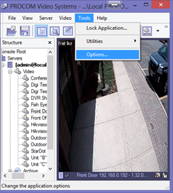
First you have to exit “Exclusivity”
  - At the main screen you will see File View Server Video Tools Help at the top
  - Click Tools Options

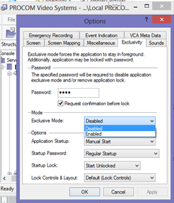
- Click the “Exclusivity” tab
  - It’s the 4th tab from the left
- There are 3 sections
  - Password
  - Mode
  - Options
- In the “Mode” section you will see a drop down menu
  - This is where you enable or disable exclusivity
  - Click the dropdown and change it to “disabled” and click OK
  - *Note - If the DVR has an older software version there will be a checkbox instead of a dropdown menu
    - Simply uncheck the box and continue
- Once you click OK you will be prompted to enter a password
  - The exclusivity password is “servicemanager”
- Once the password is entered correctly, the screen will minimize and the desktop will be visible behind the Procom Software

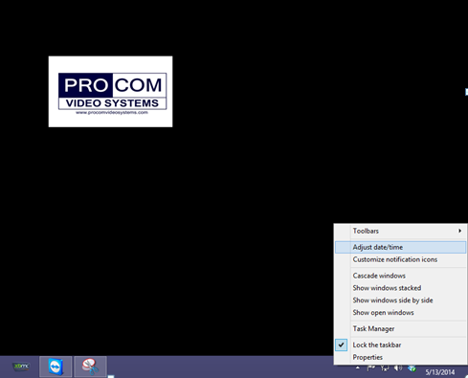
- At the bottom right-hand corner you will see the time
  - Right-click it and choose adjust date/time
- Simply adjust the date and time accordingly

- Now go back to the software and re-enable the exclusivity
  - Simply revers the steps you first took to disable
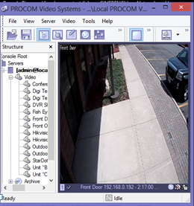
  - Tools Options Exclusivity Tab Dropdown “Enabled”
- To verify if the time correction has worked
  - Look at the bottom of one of the camera windows
  - Next to the camera name you will see the time
  - *Note – If the time is still incorrect, verify the time presentation option is correct
    - View Time presentation Server Local Time

